** Pizza Sales SQL Queries **

**KPI’s Queries**

**1. Total Revenue**

SELECT ROUND(SUM(total_price), 2) AS total_revenue FROM pizza_sales;



**2. Average Order Value**

SELECT ROUND(SUM(total_price) / COUNT(DISTINCT order_id), 2) AS avg_order_value FROM pizza_sales;



**3. Total Pizzas Sold**

SELECT SUM(quantity) AS total_pizzas_sold FROM pizza_sales;



**4. Total Orders**

SELECT COUNT(DISTINCT order_id) AS total_orders FROM pizza_sales;



**5. Average Pizzas per Order**

SELECT ROUND(SUM(quantity) / COUNT(DISTINCT order_id), 2) AS avg_pizzas_per_order FROM pizza_sales;



**Charts Queries**

**1. Hourly Trend for Total Pizzas Sold**

SELECT

HOUR(order_time) AS order_hours,

SUM(quantity) AS total_pizzas_sold

FROM pizza_sales

GROUP BY order_hours

ORDER BY order_hours;

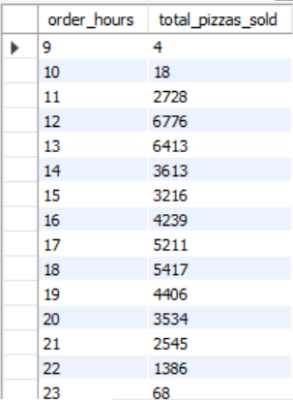

**2. Weekly Trend for Total Orders**

SELECT

YEAR(order_date) AS year,

WEEKOFYEAR(order_date) AS week_num,

COUNT(DISTINCT order_id) AS total_orders

FROM pizza_sales

GROUP BY year, week_num

ORDER BY year, week_num;

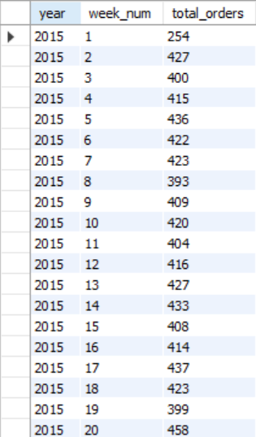 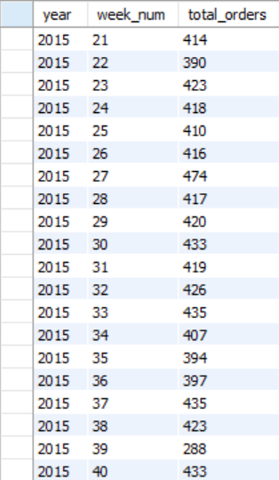 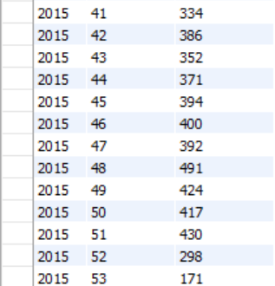

**3. Percentage of Sales by Pizza Category**

SELECT

pizza_category,

ROUND(SUM(total_price), 2) AS total_revenue,

ROUND(SUM(total_price) * 100

/ (SELECT SUM(total_price) FROM pizza_sales), 2) AS pct_total_revenue

FROM pizza_sales

GROUP BY pizza_category

ORDER BY total_revenue DESC;

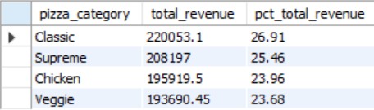

**4. Percentage of Sales by Pizza Size**

SELECT

pizza_size,

ROUND(SUM(total_price), 2) AS total_revenue,

ROUND(SUM(total_price) * 100

/ (SELECT SUM(total_price) FROM pizza_sales), 2) AS pct_total_revenue

FROM pizza_sales

GROUP BY pizza_size

ORDER BY total_revenue DESC;

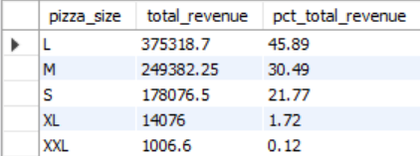

**5. Total Pizzas Sold by Pizza Category**

SELECT

pizza_category,

SUM(quantity) AS total_pizzas_sold

FROM pizza_sales

GROUP BY pizza_category

ORDER BY total_pizzas_sold DESC;

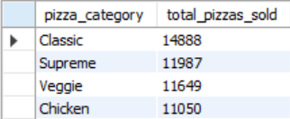

**6a. Top 5 Best Sellers by Revenue**

SELECT

pizza_name,

ROUND(SUM(total_price), 2) AS total_revenue

FROM pizza_sales

GROUP BY pizza_name

ORDER BY total_revenue DESC

LIMIT 5;

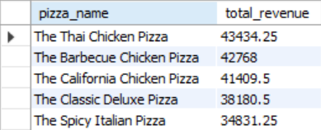

**6b. Top 5 Best Sellers by Total Quantity**

SELECT

pizza_name,

SUM(quantity) AS total_pizzas_sold

FROM pizza_sales

GROUP BY pizza_name

ORDER BY total_pizzas_sold DESC

LIMIT 5;

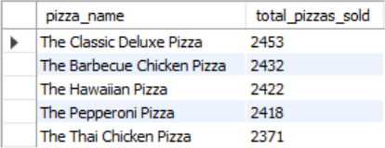

**6c. Top 5 Best Sellers by Total Orders**

SELECT

pizza_name,

COUNT(DISTINCT order_id) AS total_orders

FROM pizza_sales

GROUP BY pizza_name

ORDER BY total_orders DESC

LIMIT 5;

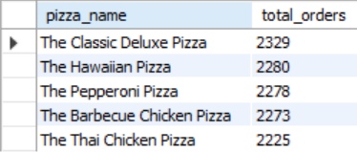

**7a. Bottom 5 Best Sellers by Revenue**

SELECT

pizza_name,

ROUND(SUM(total_price), 2) AS total_revenue

FROM pizza_sales

GROUP BY pizza_name

ORDER BY total_revenue

LIMIT 5;

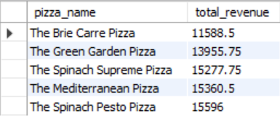

**7b. Bottom 5 Best Sellers by Total Quantity**

SELECT

pizza_name,

SUM(quantity) AS total_pizzas_sold

FROM pizza_sales

GROUP BY pizza_name

ORDER BY total_pizzas_sold

LIMIT 5;

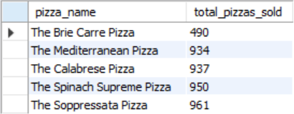

**7c. Bottom 5 Best Sellers by Total Orders**

SELECT

pizza_name,

COUNT(DISTINCT order_id) AS total_orders

FROM pizza_sales

GROUP BY pizza_name

ORDER BY total_orders

LIMIT 5;

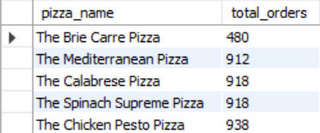

**NOTE**

To apply a pizza_category, pizza_size, order_date, order_time or other filter to the queries, you can use a WHERE clause, like this example.

SELECT

pizza_name,

SUM(quantity) AS total_pizzas_sold

FROM pizza_sales

WHERE

MONTH(order_date) IN (4, 5)

AND pizza_category = 'Chicken'

GROUP BY pizza_name

ORDER BY total_pizzas_sold DESC

LIMIT 5;

Here is for the months of April and May and the ‘Chicken’ pizza category. :)